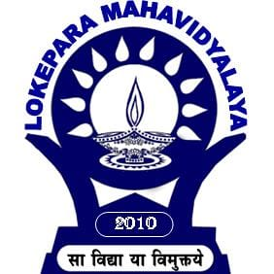 Department of History Lokepara Mahavidyalaya

Estd. 2010, affiliated to University of Burdwan

Vill.Lokepara . P.O. kuliara . Dist. Birbhum. West Bengal . Pin.731218

|  |
| --- |
| **Date – 01/09/2020** |

**Notice for Assignment Submission**

Student of Semester VI History (Hons.) 2020 are hereby informed that they will have to send four assignments respectively for four papers to the email id [dipankar.mandal800@gmail.com](mailto:dipankar.mandal800@gmail.com) by 11/09/2020. Assignments will be received in both hand written or in type form. It is mandatory for all to send the mail from their own email id. No hard copy will be received by the department. Students have to preserve the copies for future reference. The course wise topic of the assignments is given below.

**CC-13 : Foreign Policy of Adolf Hitler**

**CC-14 : Features of Globalization**

**DSE – 3: Role of Imperial Aggression at the Backdrop of 1st and Second Opium War of China**

**DSE-4: Relation Between Industrialisation and Modernisation in the Growth of Modern Japan**

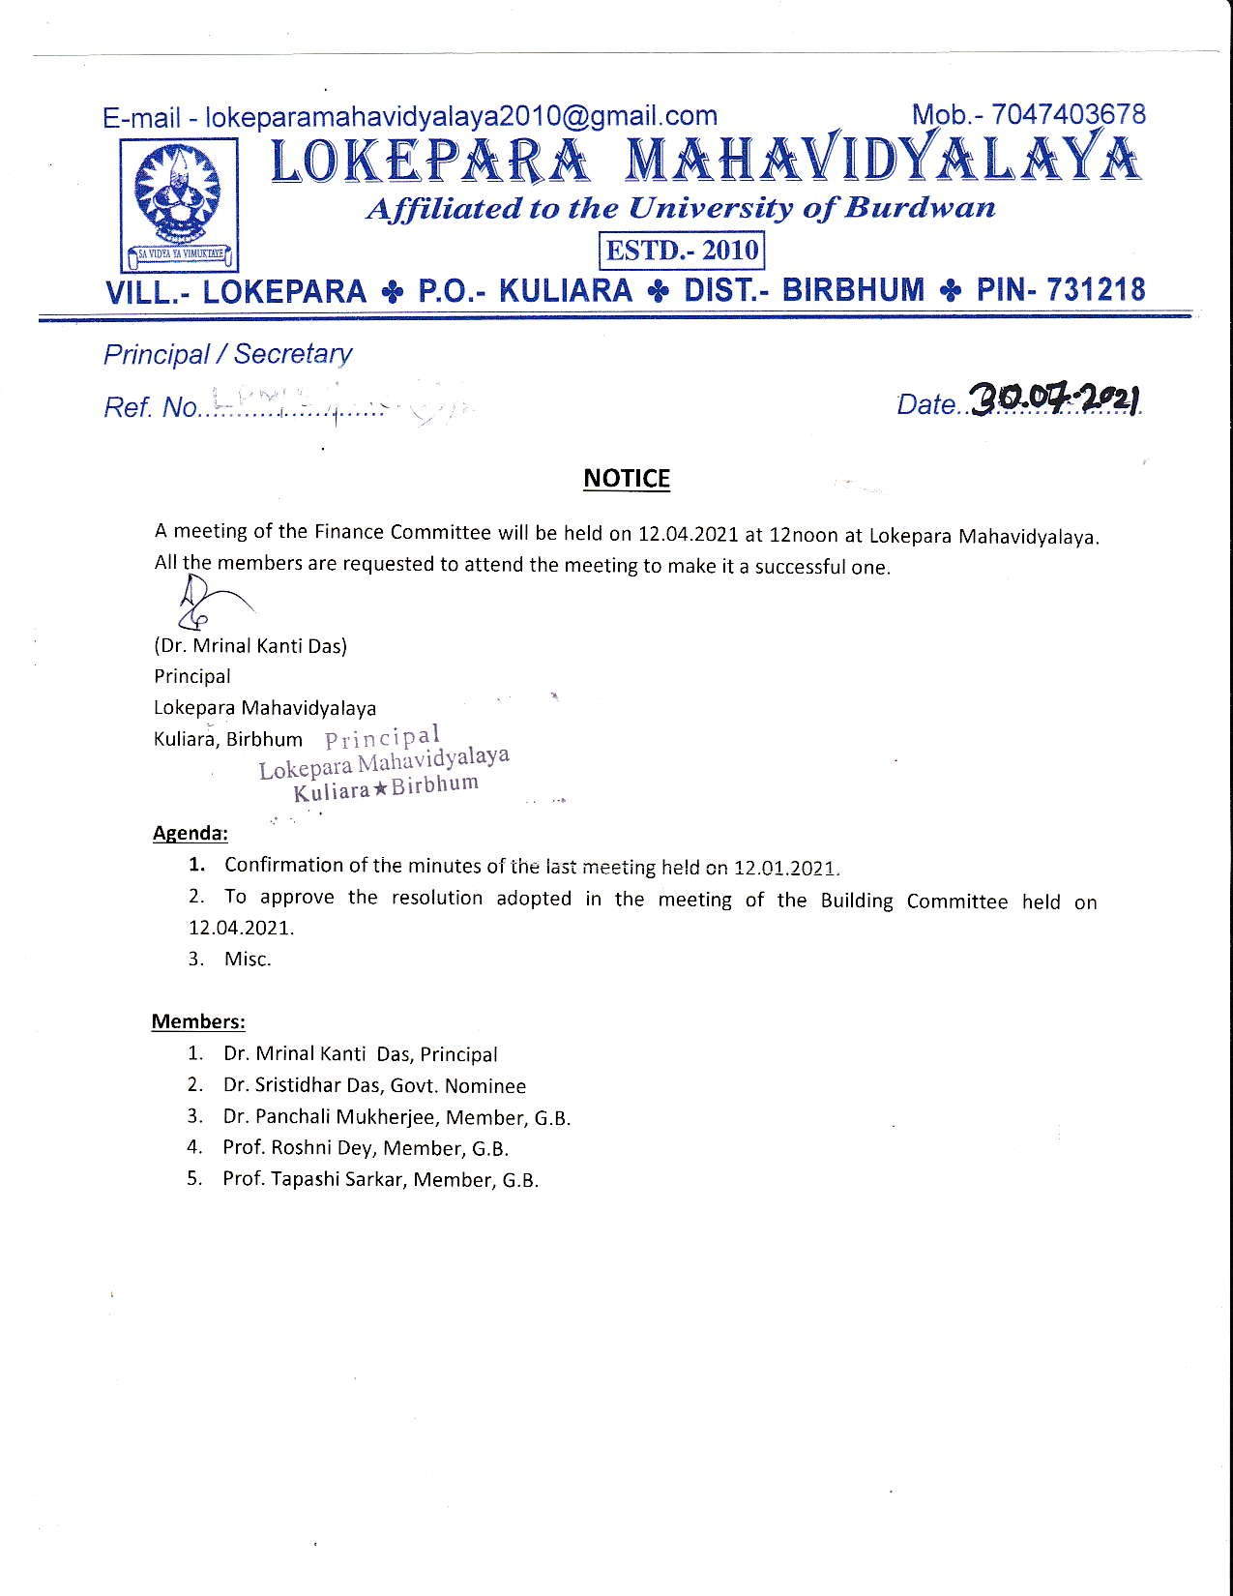

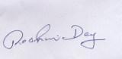

Head of the Department

History, LokeparaMahavidyalaya

Kuliara, Birbhum